Faculty of Computing

CS-212: Object-Oriented Programming
Class: BESE-16B
Instructor: Dr. M. Daud Abdullah Asif

Assignment 1 – Semester Project Proposal

“SYNERGY: A Fitness Tracking App”
By: Maryam Ateeq (549392) and M. Shahmeer Shaheedi (565007)
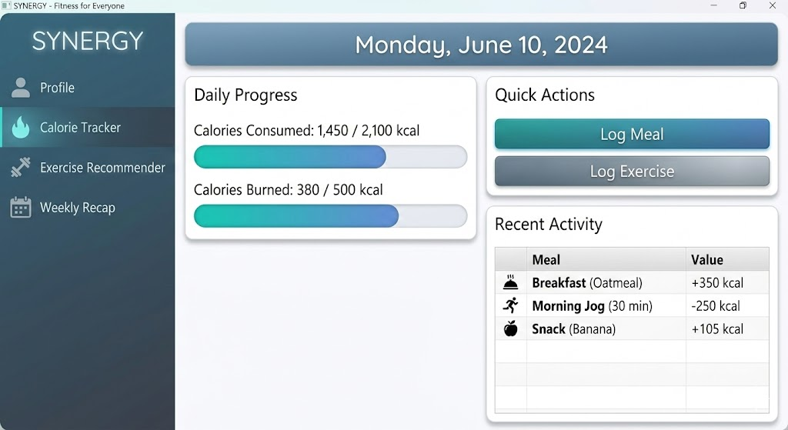

About the Project and its Objectives

Oftentimes, the best fitness advice and tools are limited to people who are willing to pay more for such facilities. On the other hand, the people who have limited economic resources tend to suffer from a lack of guidance regarding exercise, workouts, and even a diet plan. As a result, they tend to rely on intuition and basic knowledge of nutrition and fitness. This often results in underwhelming results on their physique and could (in some cases) even result in unexpected negative effects on one’s health and physique.
To address this wealth gap in the world of fitness nutrition, we’re creating SYNERGY: an app that combines both nutrition and exercise to offer a complete package to the people who can’t afford all the facilities, trainers, and supplements. “Synergy” is derived from the Greek for “working together” and is defined as a collaboration between parties and/or elements to produce a result greater than the sum of their individual efforts/capabilities. We feel this is very representative when it comes to our project, because the app is not just a calorie tracker, but also an exercise recommender based on things like your weight, age, gender, and target weight.

Scope, Features, and Functionality

Synergy, as it stands, is to have quite a few features to aid its users to the best of its potential. Currently, the proposed features are as follows:
- A gender-based exercise recommender. This would basically consider the fact that men burn more calories than women on average. Therefore, a man with a weight of 90 kg would need to engage in less exercise than a woman of the same weight to achieve a target of 70 kg.
- An age-based exercise recommender. We’re aware that elderly people would want to remain at their best possible physique, but have limited mobility, hindering their fitness journey. Hence, we can adjust the exercises accordingly (e.g a walk or a light jog instead of a sprint for cardio).
- An exercise recommender based on a target weight. For example, if a person weighing 100 kgs would need more intense exercise if he wants to get to 70 kgs rather than, say, 80 kgs.
- A daily and weekly calorie tracker. At the end of each day, you’ll input the food you’ve had for breakfast, lunch, and dinner (or a snack, if applicable) from a menu of available foods. The app will add up the calories to display the amount of calories you’ve consumed in a day, and in a week (stats to be displayed at the end of every week).
- A fractional-burned-calorie-counter. Let’s say you had to sprint for 90 minutes today to burn 1200 calories, but you could only run for an hour due to some other commitments. You could simply enter the number of minutes you ran, and the “calories burned tracker” would count the burned calories accordingly.
- A diet recommender. Let’s say you want to lose weight, but you’re consuming too many carbs. The app will analyze the amount of carbs you consume weekly, and if it’s an intake of dangerous amounts, the app will recommend that you consume fewer carbs in the weekly recap. This could be implemented for other nutrients when it comes to deficiency and over-consumption.
- A rating system based on a person’s adherence to their routine and goals. For example, if someone has to run 6 hours a week, and consume a maximum of 18,000 calories, and if a person has met those goals, they will have a higher rating compared to someone who failed to meet those goals. This will aim to motivate users to stay consistent in their weight loss journey.
- Easily accessible exercises. Instead of exercises requiring gym equipment, we will try to give users exercises that they can easily do at home with minimal facilities. We will try to recommend exercise based on a person’s physical ability (1 to 10).
These features will undergo further checks, and the decision on whether or not to include a certain feature will depend on the practicality and ease of implementation (with deadlines in mind).

Technology and Tools Involved

For this project, we shall use Java as the programming language. This decision is backed by the fact that Java is a great tool to handle conditional logic for features like an age and gender based goal-creation that depends on basal metabolism. Moreover, the modular designing in Java makes it easier to add updates. For example, if we ever have to create a Yoga feature in the future, we could simply create one as a subclass of Exercise, without having to rewrite the entire app. It can also multitask, adding data to your weekly recap as you enter your calorie consumption. Moreover, it is a high-level language, making it easier to read, and the modularity would make it easier to track the changes.
As far as UI is concerned, we plan on using JavaFX Charts to display performance ratings, create weekly charts, and enhance the overall user experience by creating an app whose features are easy to track and use.
Coming to data storing and handling, we currently plan on using File Handling for the first version of our project (the prototype) because it’s more accessible coding-wise and is easier to execute. For future prospects, though, we look to make use of more effective databases like SQL for storing and manipulating data of a large number of users (data such as calorie intake, calories burned, exercise time, weight, age, name, etc.).

Team Members

- Muhammad Shahmeer Shaheedi: He is mainly responsible for the app’s logic and interface. He will look to make the code as efficient and readable as possible.
- Maryam Ateeq: She is responsible for documenting the progress, features, and functionality etc of the app during and after its creation.
Deliverables

- A file that can run the app with all its functionalities and UI features included.
- A report that tracks the progress of the project.
- A final report covering the features, functionalities, objectives, and execution of the project/app.
- A GitHub collab repository where one can track the history of the code and report(s).

